**SUBMITTED BY :DYANA MARY C**

**SMART HOME AUTOMATION USING TINKERCAD**

**CIRCUIT DESIGN:**

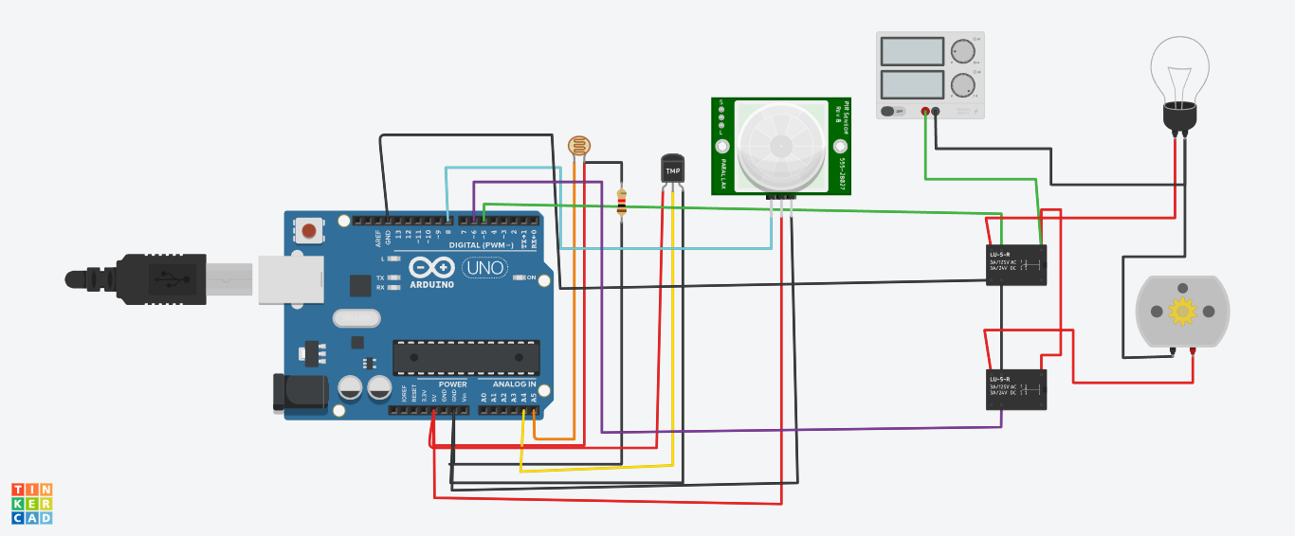

**CIRCUIT CODE:**

**floatx,y,z,temp;**

**void setup()**

**{**

**pinMode(8, INPUT);**

**pinMode(5, OUTPUT);**

**pinMode(6, OUTPUT);**

**pinMode(A5, INPUT);**

**pinMode(A4, INPUT);**

**Serial.begin(9600);**

**}**

**void loop()**

**{**

**x= digitalRead(8);**

**y= analogRead(A5);**

**z= analogRead(A4);**

**Serial.println(x);**

**Serial.println(y);**

**Serial.println(z);**

**temp = (double)z / 1024;**

**temp = temp * 5;**

**temp = temp - 0.5;**

**temp = temp * 100;**

**if ( (x>0) )**

**{**

**if ((y<550)&&(temp>30))**

**{**

**digitalWrite(5, HIGH);**

**digitalWrite(6, HIGH);**

**}**

**else if((y<550)&&(temp<30))**

**{**

**digitalWrite(5, HIGH);**

**digitalWrite(6, LOW);**

**}**

**else if((y>550)&&(temp>30))**

**{**

**digitalWrite(5, LOW);**

**digitalWrite(6, HIGH);**

**}**

**else if((y>550)&&(temp<30))**

**{**

**digitalWrite(5, LOW);**

**digitalWrite(6, LOW);**

**}**

**}**

**else**

**{**

**digitalWrite(5, LOW);**

**digitalWrite(6, LOW);**

**}**

**}**